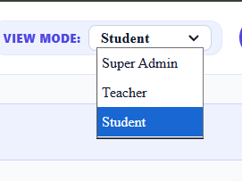
Dropdown is using default CCS properties - match it with the theme

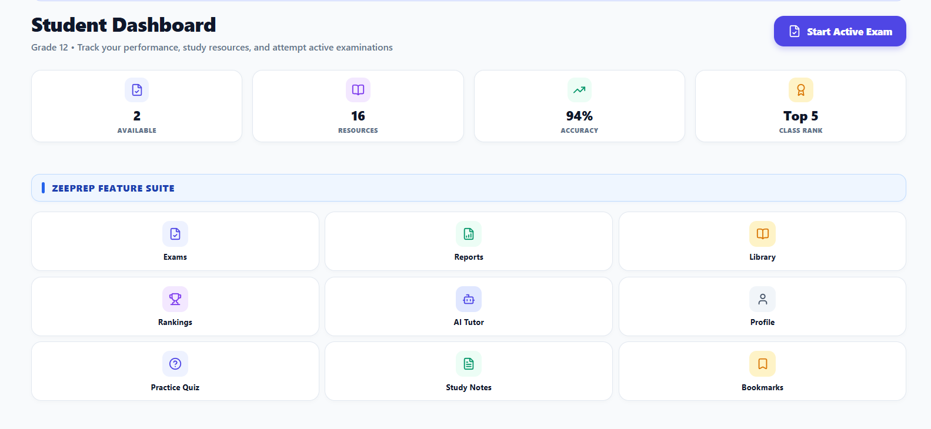
Too many features listed on the home screen, Do not add shortcuts here, just add main highlights in the form of metrics and graphs.
Also if the user is weak in any of the topics and subjects, list them here as in a focus area component(create new component)
And list subject wise topics to be focus on, and a checkbox in front and resource material shortcut button for that topic.

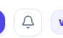
Notification button not working, it should open a side panel from the right side, even if no notification is available.

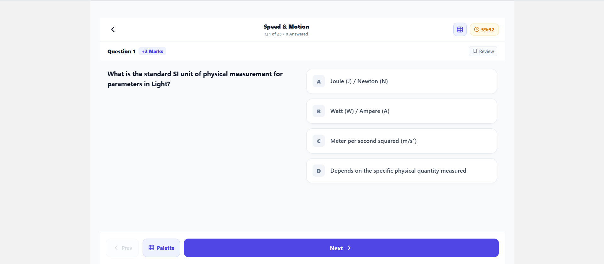
In exam screen, both the sides has empty space left, the component should be stretched 100%,, Also it has two

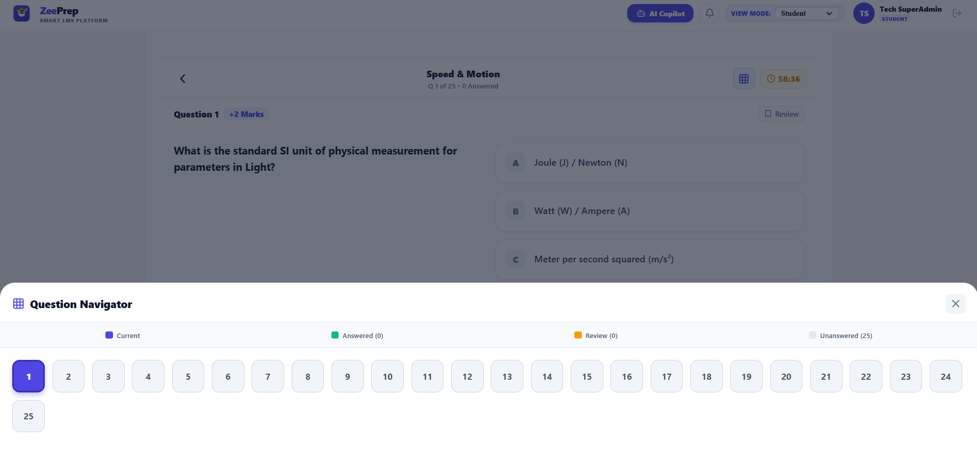
Question Navigator should not be hidden, it should be visible always

